**The Impact of AI in Employment or How has AI percolated in the workforce ?**

Rapid technological progress and innovation can threaten employment. Such a concern is not new but dates back at least to the 1930s, when John Maynard Keynes postulated his ‘technological unemployment theory’ – technological change causes loss of jobs (Keynes 1937).

Technological innovations can affect employment in two main ways:

• by directly displacing workers from tasks they were previously performing (displacement effect)

• by increasing the demand for labour in industries or jobs that arise or develop due to technological progress (productivity effect).

Autor, Levy and Murnane (2003) stress that technology can replace human labour in routine tasks, whether manual or cognitive, but (as yet) cannot replace human labour in non-routine tasks. Goos and Manning (2007) argue that the impact of technology leads to rising relative demand in well-paid skilled jobs, which typically require non-routine cognitive skills, and rising relative demand in low-paid, least-skilled jobs, which typically require non-routine manual skills. At the same time, demand for ‘middling’ jobs, which have typically required routine manual and cognitive skills, will fall. (Job polarisation)

**Acemoglu and Autor (2011) found similar results for the US, while Darvas and Wolff (2016) report such developments for a selection of EU countries: France, Germany, Italy, Spain, Sweden and the UK.**

In all these countries, the number of high-education jobs such as managers, engineers and health professionals is growing, while the number of middle-education jobs (clerks, machine operators, assemblers) is declining. By contrast, the number of low-education service occupations, such as shop workers, which are non-standard and difficult to replace by automation, is growing. A key conclusion is that technology was incorporated into the subset of core job tasks previously performed by middle-skill workers, causing substantial change.

A new wave of automation and advanced machine-learning techniques is on its way, in which intelligent machines will be increasingly capable of carrying out high-skill and possibly non-routine tasks. Moving from the efficiency gains in online trading to the extensive use of artificial intelligent systems in our industrial production, concerns about the potential displacement of labour emerge. The real question then becomes: which of the two labour market effects – displacement or productivity – will dominate in the artificial intelligence (AI) era?

Two approaches :

1. Examine the impact of technological breakthroughs on labour markets in previous industrial revolutions For example, the introduction of automobiles in daily life led to a decline in horse related jobs, but new industries also emerged, with a net positive impact on employment. The automobile industry itself grew fast, creating many new jobs. In general, past industrial revolutions suggest that in the short run the displacement effect may dominate. But in the longer run, when markets and society are fully adapted to major automation shocks, the productivity effect can dominate and have a positive impact on employment.

Researchers from the McKinsey Global Institute estimate that the disruption of society caused by AI is happening 10 times faster and at 300 times the scale of the industrial revolution of the late 18th and early 19th centuries, and is therefore having roughly 3,000 times the impact (Dobbs, Manyika and Woetzel 2015). Moreover, the main engine of technological progress in the AI era is the continuous development of deep machine-learning techniques that use the function and complexity of the human brain as a model for design (see Petropoulos 2017b).. Machines are trained to be intelligent, which can have additional implications for the workforce.

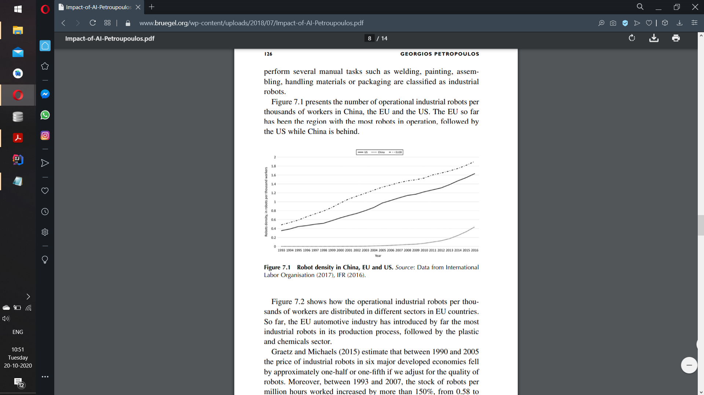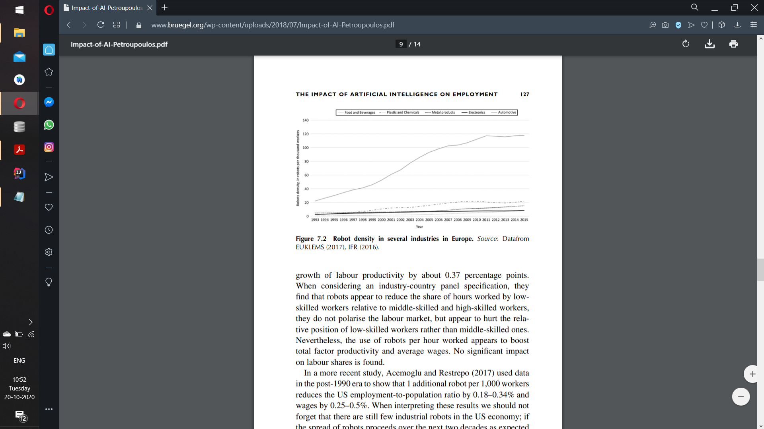

A representative article in The Guardian newspaper in early 2016 asserted that ‘Industrial Revolution 4.0’ will be shaped by a fresh wave of innovation in areas such as driverless cars, smart robotics, materials that are lighter and tougher, and a manufacturing process built around 3D printing’, bringing both ‘promise and peril’ to the world

<https://www.pnas.org/content/116/14/6531>

**Contrasting Perspectives**

***Doomsayer’s Perspective:*** Technology improves to make human labor more efficient, but large improvements may yield deleterious effects for employment. This obsoletion through labor substitution leads many to worry about “technological unemployment” and motivates efforts to forecast AI’s impact on jobs. One study assessed recent developments in AI to conclude that 47% of current US employment is at high risk of computerization , while a contrasting study, using a different methodology, concluded that a less alarming 9% of employment is at risk . Similar studies have looked at the impact of automation on employment in other countries and reached sobering conclusions: Automation will affect 35% of employment in Finland, 59% of employment in Germany , and 45 to 60% of employment across Europe. Critics have complained that prospective studies lack validation, but retrospective studies also find that robotics are diminishing employment opportunities in US manufacturing [although not in Germany].

***Optimist’s Perspective:*** Optimists suggest that technology may substitute for some types of labor but that efficiency gains from technological augmentation outweigh transition costs, and, in many cases, technology increases employment for workers who are not in direct competition with it [although recent follow-up work suggests these are temporary gains]. Furthermore, the skill requirements of each job title are not static and actually evolve over time to reflect evolving labor needs. For example, workers may require more social skills because those skills remain difficult to automate. Even if technology depresses employment for some types of labor, it can create new needs and new opportunities through “creative destruction”. For instance, the replacement of equestrian travel with automobiles spurred demand for new roadside amenities, such as motels, gas stations, and fast food.

***Unifying Perspectives:*** On one hand, multiple dynamics accompany technological change and create uncertainty about the future of work. On the other hand, experts agree that occupations are best understood as abstract bundles of skills and that technology directly impacts demand for specific skills instead of acting on whole occupations all at once. Therefore, a detailed framework that connects specific skill types to career mobility and to whole urban workforces may help to unify competing perspectives (shown in fig.). Existing studies have argued theoretically that different skill types underpin aggregate labor trends, such as job polarization and urban migration, but robust empirical validation is made difficult by the specificity of modern skills data and their temporal sparsity.

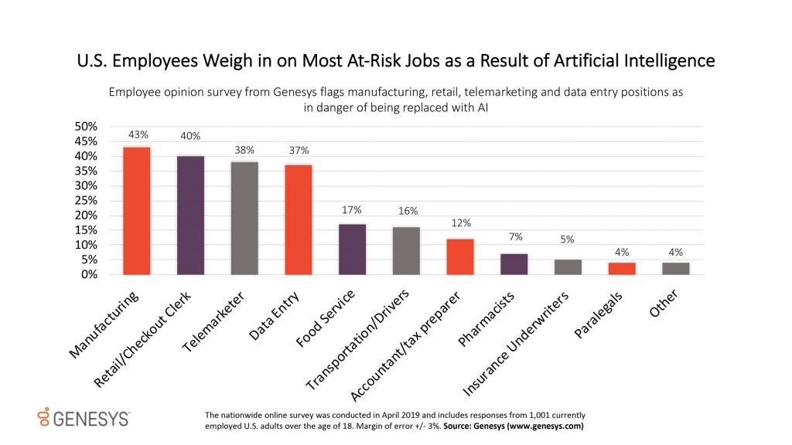

***AI and jobs impact***

In the Genesys opinion survey, 1,001 employed Americans were asked about the current and future effects of AI in the workplace. Participants across industries were asked to select the three jobs most likely to be replaced by AI from among the following options: Accountant/Tax Preparer, Data Entry, Food Service, Insurance Underwriters, Manufacturing, Paralegal, Pharmacist, Retail/Checkout Clerk, Telemarketer, Transportation/Driver, and Other.

The results showed that U.S. employees working in education/training and doctor/nurse/caregivers were the least afraid that AI/bots would take their jobs within the next 10 years. Meanwhile, those in the media and those with assembly line/manufacturing jobs were the most afraid.

Human resources employees identified data entry and retail/checkout jobs as the most likely to be replaced by AI, and equally at risk. Employees working in customer service, which tend toward pessimism, the study said, chose the jobs of retail/checkout clerk and telemarketer as the most likely to suffer from AI.

***Additional insights from the survey included:***

1. Across age groups, U.S. employees believe that paralegals (4%), insurance underwriters (5%), and pharmacists (7%) have the best chance to survive automation;
2. More part time employees (25%) fear that AI will take their jobs within 10 years compared to full-time workers (18%), although there is no significant difference in attitudes on the specific jobs they think are likely to disappear.
3. Employees at the largest companies (with more than 20,000 staff) are slightly less afraid (17%) than the overall group (19%) about the effect of AI/bots on their jobs, possibly because they have already experienced its negative impact (10%), and see a more stable future.

**Research questions**

***The focus is on the following questions:***

* How can AI support learning?
* What role does AI play in the digital transformation of science, society, industry, culture etc.?
* How can AI work in line with the GDPR (General Data Protection Regulation), and what are the limits?
* Which of the data already collected or soon to be collected may serve for AI concepts/projects?
* Is AI only for computer scientists? How can humanities scholars participate in and contribute to the potentials of the new technologies?

***Topics***

* Artificial Intelligence
* Digital Humanities
* Digital Learning and Teaching
* Computer Vision
* Virtual Reality
* Augmented Reality
* Serious Games

References

Fernald, J.G. (2015), “Productivity and Potential Output before, during, and after the Great Recession,” in *NBER Macroeconomics Annual 2014*, edited by J.A. Parker, and M. Woodford. Chicago: University of Chicago Press, 1–51.

Frey, C.B., and M.A. Osborne (2013), “The Future of Employment: How Susceptible Are Jobs to Computerisation?” mimeograph, Oxford Martin School.

Mokyr, J., C. Vickers, and N.L. Ziebarth (2015), “The History of Technological Anxiety and the Future of Economic Growth: Is This Time Different?” *Journal of Economic Perspectives* 29, 31–50.

Morikawa, M. (2015), “Postgraduate Education and Labor Market Outcomes: An Empirical Analysis Using Micro Data from Japan,” *Industrial Relations* 54, 499–520.

Morikawa, M. (2016), “The Effects of AI and Robotics on Business and Employment: Evidence from a Survey on Japanese Firms,” RIETI Discussion Paper, 16-E-066.